**Group A: Assignment No:12**

**Problem Statement:**

**Implementation of a direct access file -Insertion and deletion of a record from a direct access file.**

**Program:**

**main.py**

# Python program to demonstrate

# Read record in a file

# Open function to open the file "myfile.txt"

# it's reference in the variable file1

file1 = open("myfile.txt")

# Reading from file

print(file1.read())

# Closing file

**file1.close()**

Output:

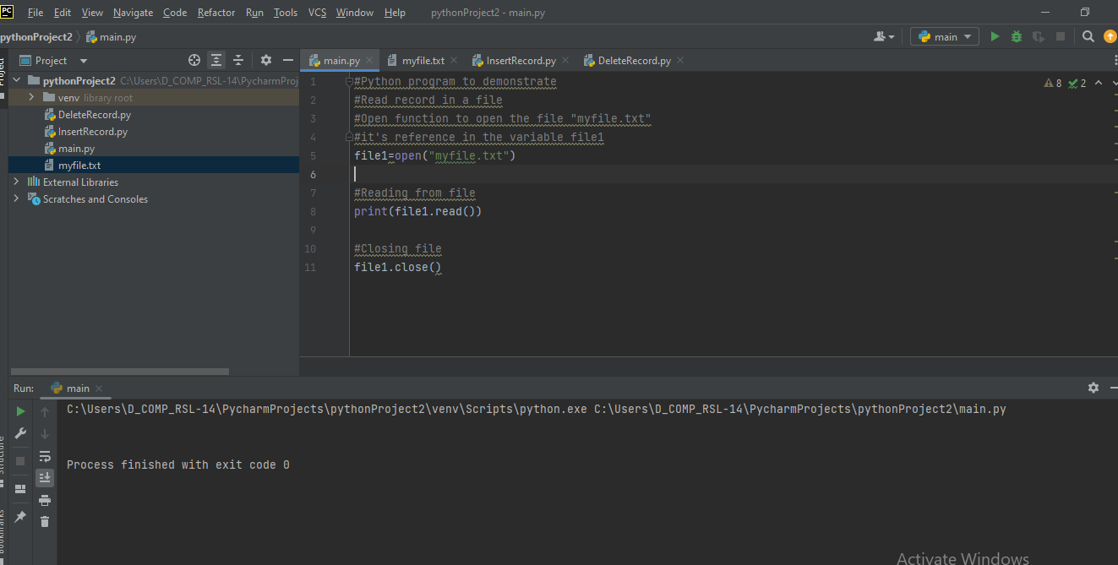

**InsertRecord.py**

# Python program to demonstrate

# insert record in a file

# Open function to open the file "myfile.txt"

# (same directory) in append mode and store

# it's reference in the variable file1

file1 = open("myfile.txt", "a")

# Writing to file

file1.write("\nWriting to file :)")

# Closing file

**file1.close()**

**Output:**

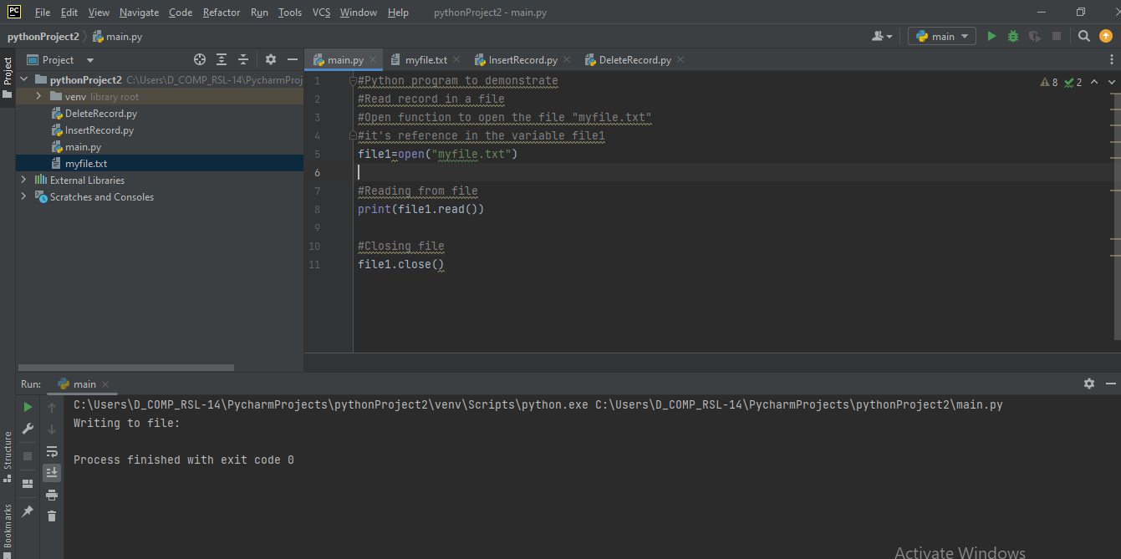

**Deleterecord.py**

# code to delete a particular

# data from a file

# open file in read mode

with open("myfile.txt", "r") as f:

# read data line by line

data = f.readlines()

# open file in write mode

with open("myfile.txt", "w") as f:

for line in data :

# condition for data to be deleted

if line.strip("\n") != "Age : 20" :

**f.write(line)**

**Output:**

